**Lab manual 3!**

**Learning Objectives:**

The objectives of this first experiment are to make you familiar with data types, identifiers, basic operators, expressions and basic input/output.

**Example 1:**

Write a C++ program that finds the sum of two numbers.

**Code:**

#include<iostream> using namespace std;

/* function main begins program execution */ int main()

{

int num1=5; /* initializing an integer variable num1 to 5 */

int num2=9; /* initializing a variable num2 of integer data type */ int sum=0; /* variable sum in which sum will be stored */

sum= num1 + num2; /* Adding both number */ cout<<"The sum is: "<<sum;

return 0; /* indicate that program ended successfully */

} /* end function main */

**Task 1:**

Write a C++ program to perform the basic arithmetic operations (addition, subtraction, multiplication, division, remainder).

**Input :**

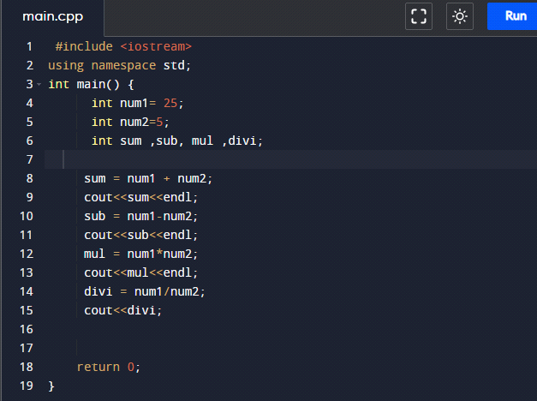

Output :

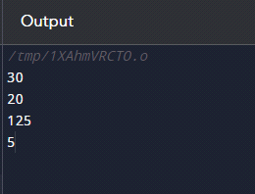

**Example 2:**

Write a C++ program that input two numbers from user and calculate their sum .

**Code:**

#include<iostream> using namespace std;

/* function main begins program execution */ int main()

{

int num1, num2, sum; /* declairing variables */ cout<<"Enter two numbers";

cin>>num1>>num2; /*Reading two numbers from user */ sum= num1 + num2; /* Adding both number */

cout<<"The sum is: "<<sum; /* Display the result of addition */ return 0; /* indicate that program ended successfully */

} /* end function main */

**Task 2:**

Write a C++ program that input two numbers from user and calculate basic arithmetic operations (addition, subtraction, multiplication, division, remainder).

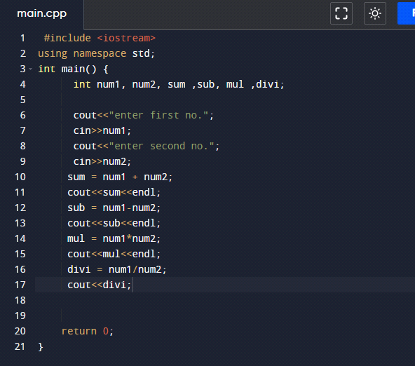

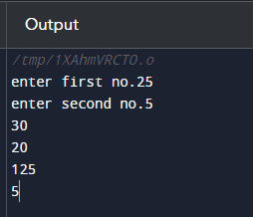

**Task 3:**

Write a C-Program to calculate area and Perimeter of the triangle and rectangle. [Area of triangle= ½ x base x vertical height , Perimeter of triangle = a + b + c]

[Area of rectangle= width x height , Perimeter of rectangle = 2( a + b)]

**Input :**

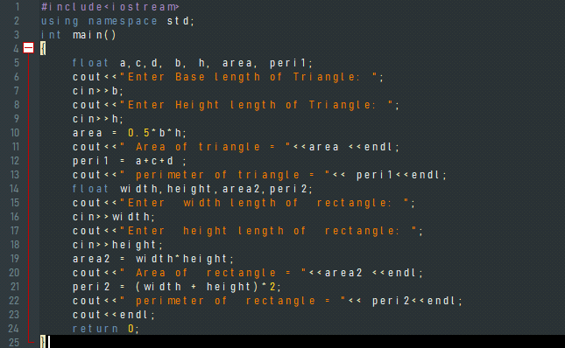

**Output :**

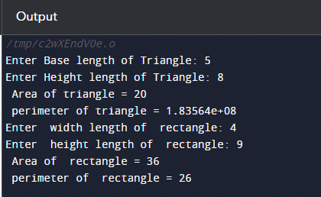

**Task 4:**

Write a C++ program to enter temperature in Fahrenheit and convert to Celsius.

**Input :**

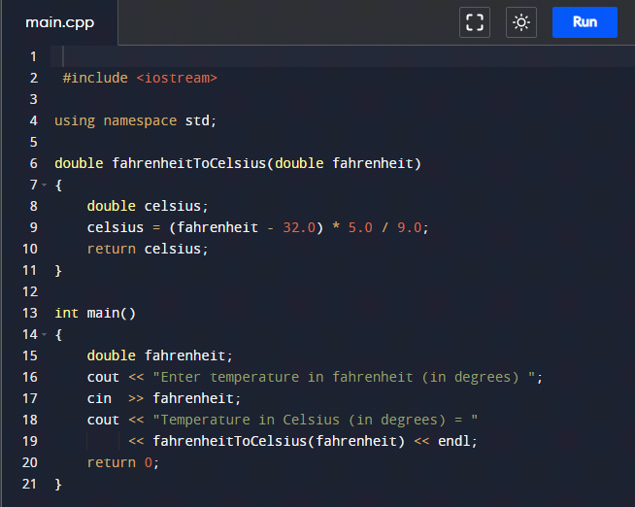

**Output :**

